CODE3000 HACAKATHON

**1**

***MAGIC SQUARE: (500 Points)***

It was the time where mathematicians are creating wonders in the field of science. A meeting had been held in Wuhan regarding the 100th birthday of Albert Einstein. All the mathematicians around the world gathered in that wonderful event. Two renowned scientists from India, Ram and Tarun are one of them. There had been meetings, games, fun etc., During the event a stage show was performed by a Student from Wuhan named CARONA. She had taken a black board and had drawn a 7x7 square block and had filled it with numbers. After she completed her drawing all the mathematicians gave her a standing ovation. Such was the importance of the that square and from there it was called as MAGIC SQUARE. Tarun And Ram were so impressed by her technique and wanted to build more advanced solution to it. Help Tarun and Ram to get the best solution to the MAGIC SQUARE.

MAGIC SQUARE is a nxn square block where it is filled with 1 to n2 numbers where the sum of any horizontal, vertical and diagonal numbers is same.

**INPUT FORMAT:**

n, positive odd Integer

**CONSTRAINTS:**

n<100

**OUTPUT FORMAT:**

n-1 line separated numbers where each line has n-1 tab separated numbers.

**SAMPLE INPUT-1:**

3

**OUTPUT:**

8 1 6

3 5 7

4 9 2

**SAMPLE INPUT-2:**

5

**OUTPUT:**

17 24 1 8 15

23 5 7 14 16

4 6 13 20 22

10 12 19 21 3

11 18 25 2 9

**CLUE:** See how the numbers are traversing in the square.

CODE3000 HACAKATHON

**2**

***TRIANGLE IN TRAINGLE IN……………IN TRAINGLE: (500 Points)***

Equilateral triangle is a triangle where all sides and angles are equal. We can divide an equilateral triangle into 4 congruent equilateral triangles. Our task is to build a congruent system of triangles with in a triangle which is a fractal and fixed set of an equilateral triangle which subdivides recursively into smaller triangles.

**INPUT FORMAT:**

n, positive Integer which is power of 2.

**CONSTRAINTS:**

n<1025

**OUTPUT FORMAT:**

Required triangle from the input which is formed by “.”

**SAMPLE INPUT-1:**

4

**OUTPUT:**

**.**

**. .**

**. .**

**. . . .**

**SAMPLE INPUT-2:**

8

**OUTPUT:**

**.**

**. .**

**. .**

**. . . .**

**. .**

**. . . .**

**. . . .**

**. . . . . . . .**

**SAMPLE INPUT-2:**

16

**OUTPUT:**

**.**

**. .**

**. .**

**. . . .**

**. .**

**. . . .**

**. . . .**

**. . . . . . . .**

**. .**

**. . . .**

**. . . .**

**. . . . . . . .**

**. . . .**

**. . . . . . . .**

**. . . . . . . .**

**. . . . . . . . . . . . . . . .**

CODE3000 HACAKATHON

**3**

***CARONA NUMBER: (500 Points)***

Carona virus has been the talk of the town all over the world which affected thousands of people in just 70 days. Scientists has no clue how this virus is rapidly spreading all over the world. Many doctors and microbiologists are in the search of the vaccine for it. A microbiologist from India named Ram has noted the growth pattern of Carona virus on the human body. It follows some mathematical logic in splitting of virus day by day. Let say there are **n** thousand virus on the skin on day 1. The rapid increase of virus follows the below pattern in simultaneous day.

1, 5, 32, 288, 3413, 50069, 873612,………..

If they are able to get the logic behind the replication there would be some chance of discovering a vaccine.

Help Ram to crack the logic behind the virus replication.

**INPUT FORMAT:**

n, positive integer

**CONSTRAINTS:**

n<100

**OUTPUT FORMAT:**

Positive integer

**SAMPLE INPUT-1:**

10

**OUTPUT:**

10405071317

**SAMPLE INPUT-2:**

13

**OUTPUT:**

312086923782437

CODE3000 HACAKATHON

**4**

***LARGEST BINARY DIFFERENCE: (500 Points)***

Ram and Venkat are always competitive with each other and sportive too. Once they went to a technical event held at IIT Mumbai. It is a CSE event and they have participated in many competitions through-out the day where both of them got equal number of merit certificates. There is a final competition in the event and all the people gathered around a big hall. It is a coding competition where each has to bet their amount to do the coding task and if she/he wins they will get 10x money what he/she has put into the bet.

Both Venkat and Ram were excited about it and they were the only people who came forward to participate in the competition. Each of them has kept 1000/- as bet. So, the question they have been given is:

Given a binary string of 0s and 1s. The task is to find the maximum difference between the number of 0s and number of 1s in any sub-string of the given binary string. That is maximize (number of 0s – number of 1s) for any sub-string in the given binary string. If no such string has found print -1.

You are the audience over there if any one solves the question they have a chance of free entry in to the competition.

**INPUT FORMAT:**

n, binary string

**CONSTRAINTS:**

Length of n <10000

**OUTPUT FORMAT:**

Integer.

**SAMPLE INPUT-1:**

11000010001

**OUTPUT:**

6

**SAMPLE INPUT-2:**

11111

**OUTPUT:**

-1

**SAMPLE INPUT-3:**

100001

**OUTPUT:**

4

CODE3000 HACAKATHON

**5**

***TIME KILLER vs SCORE GETTER: (500 Points)***

Company named **VERSUS** is conducting a coding competition named CODE 3000. They are bored of making manual entries into an excel file. They want you to help them by making a console application. They are more particular about the design of the application. It must be **Object Oriented Design.** Here’s the description.

* They will store the data in a text file named **db.txt** in the following format.
  + Name Roll No CGPA Branch
  + Delimiter is a tab space
* Create a class called Participant with attributes:
  + Name
  + Roll No
  + CGPA
  + Branch
* Add the following methods in the class Participant:
  + **isValidName:**  Validates participant name
    - **Constraints:**
      * Should be a single word with all alphabets
      * On Violation should print **Invalid Name**
  + **isValidRollNo**: Validates the roll no and if valid parses it to get the branch from Roll No.
    - **Constraints**:
      * Roll Number should be of length 10
      * On violation should print **Invalid Roll No**
      * First two characters should represent the year of joining
      * On violation should print **Invalid Year**
      * The next two characters should be ‘A3’ as only Pragati people can participate in Code 3000
      * On violation should print **Not a student of Pragati Engineering College**
      * The next two characters should be either ‘1A’ or ‘5A’ which represent whether they are regular joiners or lateral entries
      * On violation should print **Not a valid Student**
      * The next two characters denote the branch:
        + 01: CIVIL
        + 02: EEE
        + 03: MECH
        + 04: ECE
        + 05: CSE
        + 12: IT

Any other code should print **Invalid Branch**

Last two characters are of no constraints.

* + **isValidcgpa:** Validates CGPA
    - **Constraints:**
      * Should be strictly in between 0.0 and 10.0
      * Should be represented in decimal format even for 10 CGPA
      * On Violation should print **Invalid CGPA**
  + **toString:** Converts the participant object into a string to add to our text file
  + **add_participant:** Add the participant into our text file.
  + **update_particpant:** Updates the details of existing participant in our text file.
  + **delete_participant:** Delete the participant from our text file by taking only his Roll No as input.
  + **validate_participant:** Used to call all the validation functions and print the foremost violation.
* Create utility functions which helps you deal with the input, our Participant class and our text file.
* **Console Application Description:**

Here’s the screenshot which help you build the application as we want.

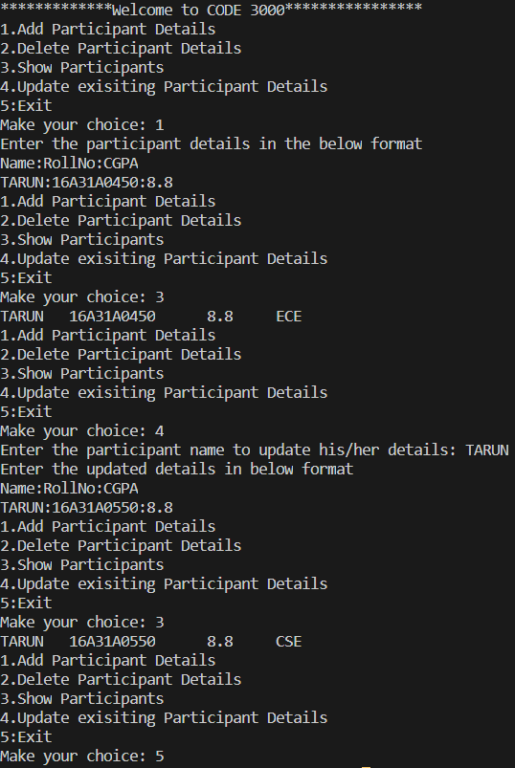

**UPDATING EXAMPLE**

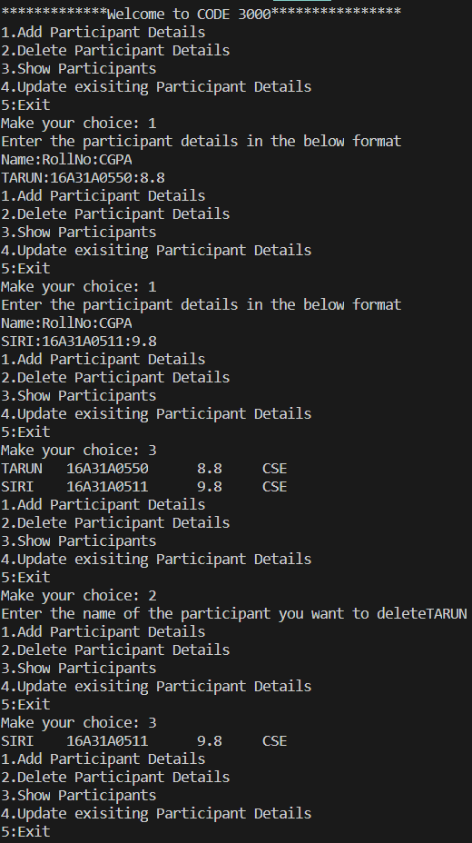

**DELETING EXAMPLE**

CODE3000 HACAKATHON

**6**

***IMPRESS THE JUDGE: (500 Points)***

Everyone has their own talents. Some are good at math, some are good at painting, some are good in sport, some are good in public speaking, some are good in coding and some are good at all or none. Each have their own talent to prove in their lives. This is one of the opportunities you get to prove your special talent. You got one hour of time with you and come with an interesting programming logic which should be creative and unique to the judges.

The programming logic may include but not limited to:

* A number series
* A pattern
* Fastest algorithm to any of the programming questions that are famous
* Your own python games
* Dealing with any mathematical puzzles etc.,

This is one of the ways we test your logical ability, creativity and how well versed you are in python programming language.

The metrics we check here are but not limited to:

* Code complexity
* Time complexity
* Space complexity
* Creativity
* Problem solving
* Variable names
* Comment lines
* Libraries you use.

So, be careful while attempting this question as you have only 1 hour and already 5 min have completed so hurry up, sharp you brain, and do well. **ALL THE BEST.**